**PROJECT**

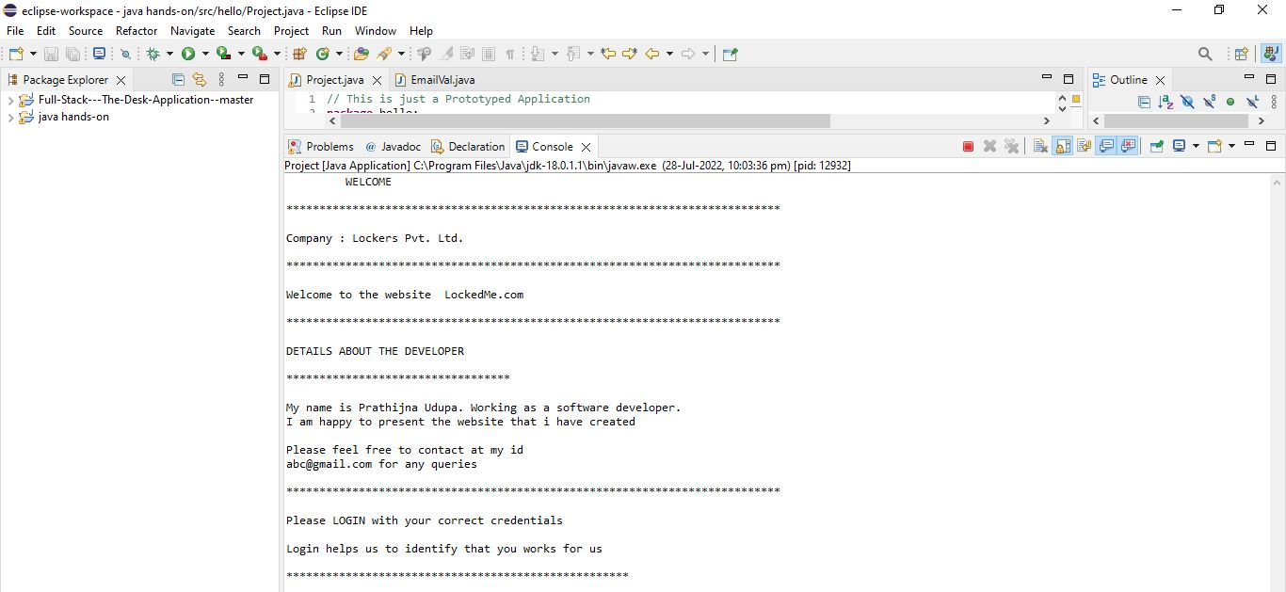

* A welcome message is displayed.
* Then Company name is displayed as mentioned in the problem statement
* Then the website name is mentioned, as per given statement.
* Details of the developer is mentioned, and support email id is provided.
* For authentication purpose, if the person belongs to the company, he will be provided with the company email id.

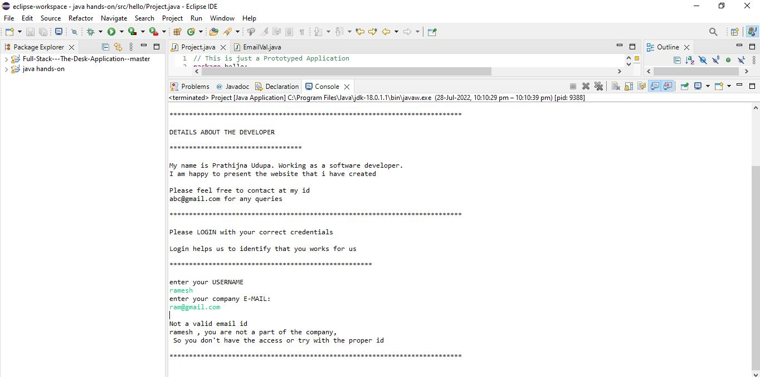

* User have to enter username.
* Then user enters the company email id.
* If the id entered by the user is wrong, that means he is not a part of the company.
* Else he can retry with the correct credentials.

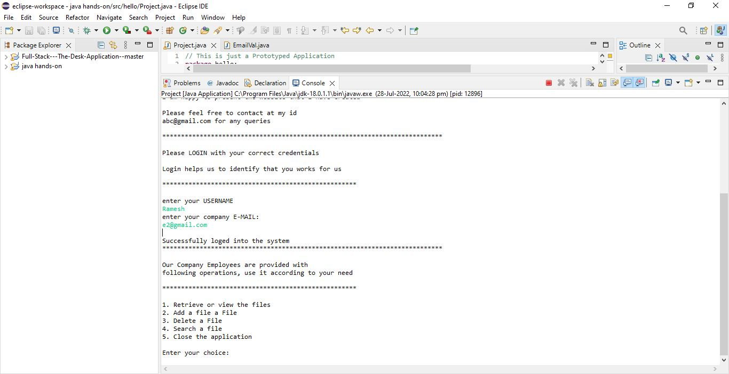

* User enters username.
* User enters email id.
* When user enters correct credentials, then successfully loged in message will be displayed.
* If the user is loged in to the system, that means he belongs to the company.
* So user will get certain operations to do.
* User can retrieve the files which are available in the list
* User can add the file to the list
* User can delete the file.
* User can search a specified file.
* Then user can close the application

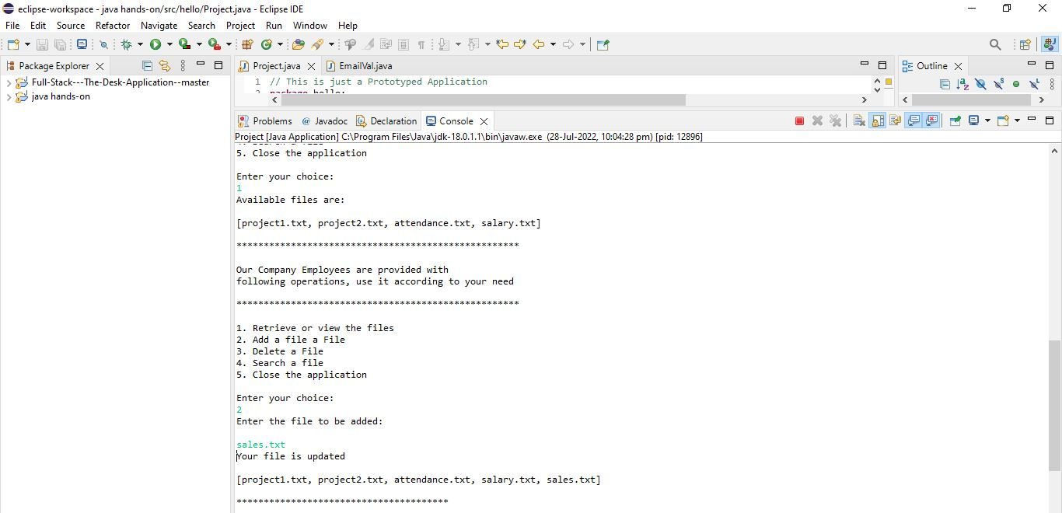

* Choice made is one, retrieve or view the files
* It displays all the files in the system as available files are.
* Choice made is two, that is to add a new file
* It will ask you to enter new file, user will enter the file.
* It will be updated in the list.
* Updated list will be displayed.

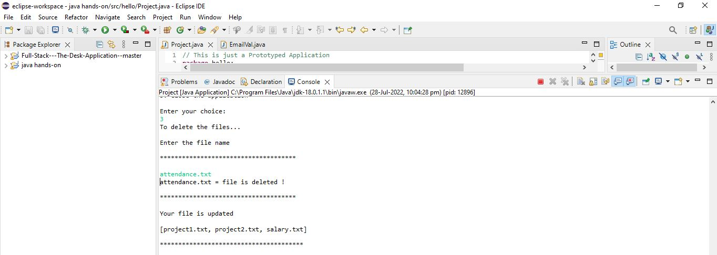

* Choice made is 3, to delete the file from the list.
* It will ask you to enter the file name that you wish to delete.
* Then file will be deleted from the list.
* Updated list will be displayed.

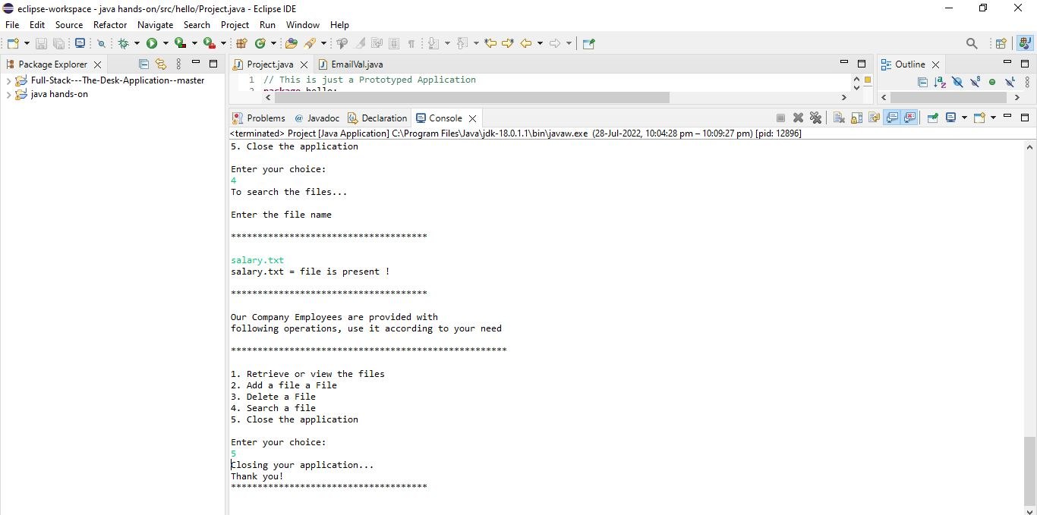

* Choice made is four, here user can search the file.
* If file is found in the list, it will be displayed.
* Otherwise file not found message will be display.
* Next choice is 5 that is to close the application.
* Closing your application…, thank you message will be displayed.